
CELLos
Technical documentation for the IRENA cell engineering operating system
Version 1.0 · 22 September 2026 · Prepaire Labs
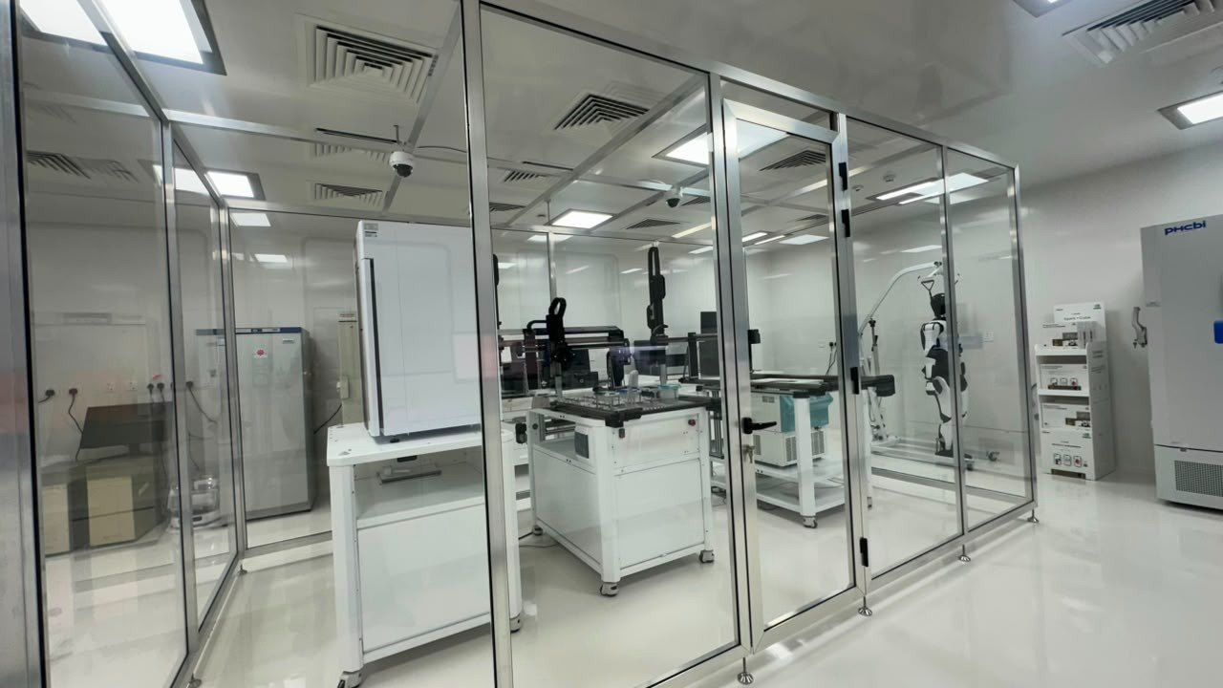
Figure 1. IRENA BSL-3 glass workcell suite, Masdar. Dual gantry, NeXCell automated incubator, closed-room humanoid.
This document is written for two readers at once. If you have never run a cell-therapy robot, start at §1 and follow the SAT-7 walk-through in §4. If you already live in LIMS, liquid classes and SAT protocols, skip to §6–§11: architecture, hardware boundary, identity model, gap matrix and Feynman deployment. The same facts are used in both paths. Nothing here is a clinical claim.
Contents
1. What CELLos is (and is not)
2. The room you are looking at
3. First hour on the system
4. SAT-7 — the seven-day acceptance run
5. Every screen, in order
6. Cell programmes and product kinds
7. Safety: dyes, switch, laser, residual iPSC
8. Identity, banks and the batch record
9. Hardware boundary and connected systems
10. Software architecture
11. Feynman App Store deployment
12. Gap matrix (as of September 2026)
13. Glossary
14. Troubleshooting
1. What CELLos is (and is not)
CELLos (spoken “cell-os”) is the laboratory execution system for Prepaire’s IRENA induced pluripotent stem cell (iPSC) robot. You do not pipette in this application. You declare a cell programme — which bank, which protocol, which dyes, whether a suicide switch or laser is in scope — and the software turns that declaration into a timed, identity-safe run on the deck.
Think of it as the cockpit of a closed workcell rather than a notebook. The gantry moves plates. The NeXCell incubator holds them at 37 °C and 5% CO₂. CELLos is the layer that knows which plate is which, which step is legal, and which decision still belongs to a human.
1.1 Three rules that never move
- Identity first. If the plate barcode, incubator slot and run ID disagree, the robot holds. It does not guess.
- The robot advises; people dispose. RED morphology, unique material, laser, and iCasp9 all require a human. Two people for kill mechanisms.
- Images are not a release. Residual undifferentiated iPSC is signed out by a molecular or flow assay, not by a well photograph.
1.2 What this edition simulates
The photographs in the brochure are of the real Masdar installation. The live telemetry in this software edition is a faithful simulation of IRENA-BIO-SOP-001 (feeder-free iPSC cycle) and IRENA-BIO-RDP-002 (TumorDressed dendritic cells) so operators can rehearse before coating, optics and cold-cytokine stations are SAT. Simulated GREEN is not a clinical pass.
Research use only. CELLos is not a medical device, not a manufacturing authorisation, and not a substitute for site SOPs, ethics, or GMP translation.
2. The room you are looking at
IRENA sits in a glass isolator with HEPA supply, CCTV and a cassette-style automated incubator. Two Cartesian gantries share plate nests. A closed-room humanoid stands outside the sterile path for trolley moves and kit presentation. NVIDIA Spark-class compute sits on a rack for onboard inference that must never ride the gantry.
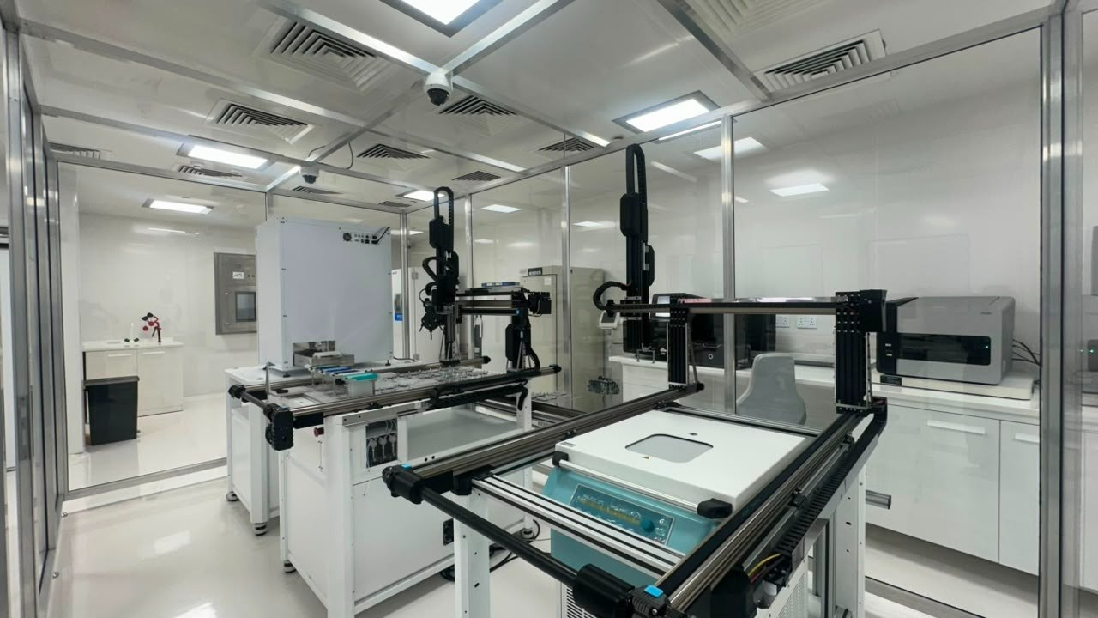
Figure 2. Dual gantry liquid handlers and plate nests inside the glass envelope.
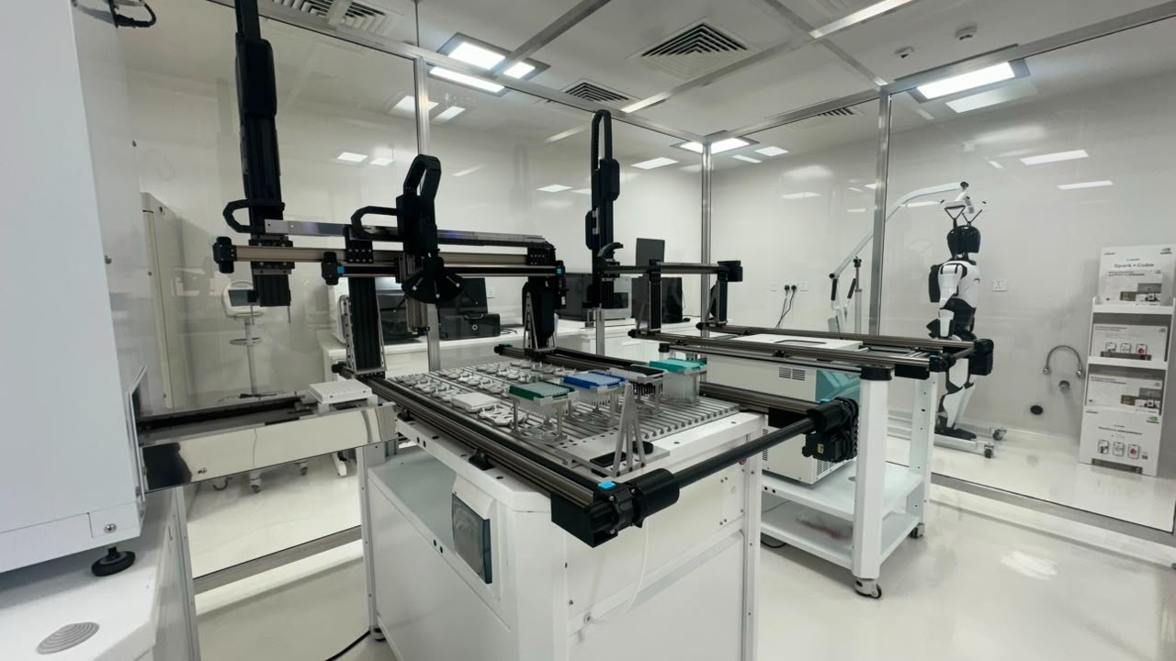
Figure 3. 6-well / 96-well deck. Humanoid assistant visible through the right-hand glass.
The teal-lidded instrument on the right-hand station is the connected automated incubator (NeXCell R series from Waken Tech). CELLos treats it as an environmental sidecar: temperature, CO₂, optional O₂, humidity, cassette slot, and load/unload under 25 seconds. Communication is RS-232 / RS-485 and Ethernet. The incubator can sit against a cell-processing isolator or biosafety cabinet — which is exactly how it is installed here.
2.1 Why a master cell bank, not a patient iPSC each time
The platform schematic (Figure 4) is the commercial logic of the workcell. A single multiplex-edited iPSC is clonally sorted. One candidate clone is expanded into a clonal master cell bank. Manufacture then starts from a vial. The output is stored drug inventory that can treat thousands of patients on demand. Patient blood and tumour still matter — they build the test environment (vesicles, organoids, chips), not the manufacturing chassis.
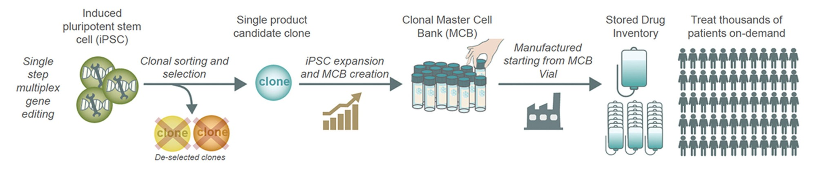
Figure 4. Prepaire iPSC platform: multiplex edit → clonal sort → MCB → manufacture from vial → on-demand treatment.
3. First hour on the system
You do not need LIMS experience. You need a browser and fifteen quiet minutes.
- Open Command. You should see SAT-7 running, a six-well plate, incubator numbers around 37.0 °C / 5.0% CO₂, and an Optics GAP chip. That GAP is honest — the inline imager is not SAT.
- Tap wells A1 through B3. GREEN means the simulated classifier would feed. YELLOW means review, not automatic passage. RED holds autonomous reseed.
- Open Brochure. Match the photographs to the glass room. This is how you learn the deck without standing in BSL-3.
- Open Cell Builder. Paste: “Universal MHC-deficient dendritic cells dressed with U266 tumour membranes, NANOG suicide switch, TRA-1-60 laser gate.” Press compose. A programme appears with the qKO bank, RDP-002 protocol, and the right dyes.
- Open the programme. Dispatch to robot. The run console is the operator’s home: speed 1× / 8× / 30× is for rehearsal only.
- Open Safety. Try the laser. It will refuse until both the operator (C. Freer in the demo) and the reviewer (Prof Min) arm it. That refusal is the feature.
- Download this Word file and the PDF brochure from Command or Guide so the next person on shift has the same pack.
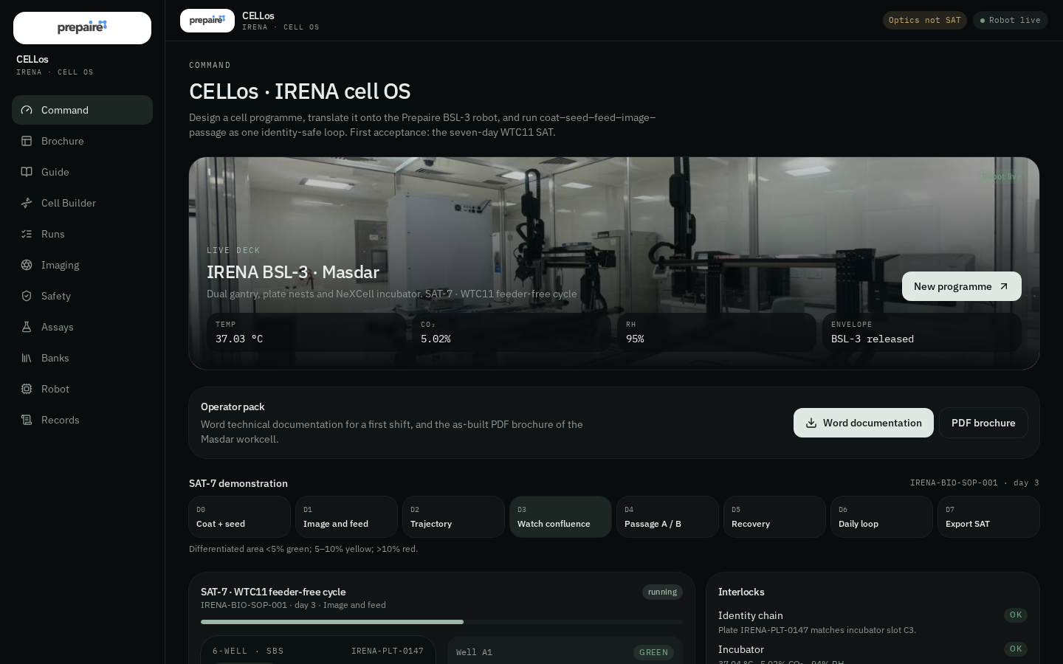
Figure 3a. Command — live SAT-7, incubator, operator pack, six-well plate.
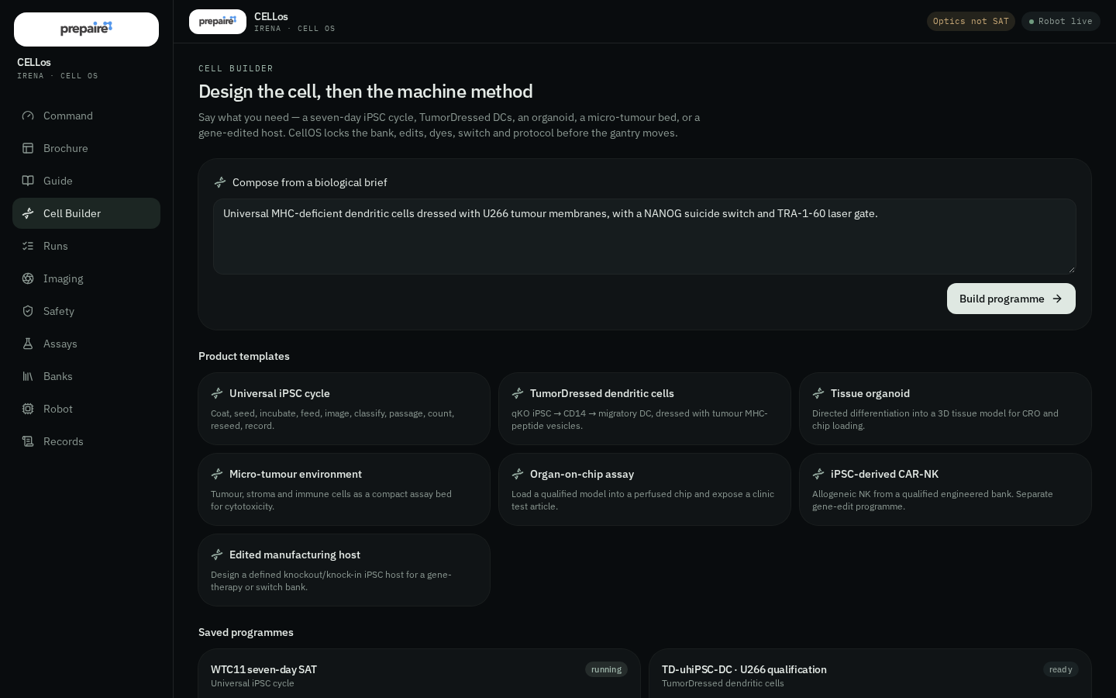
Figure 3b. Cell Builder — compose a programme from a sentence, then dispatch.
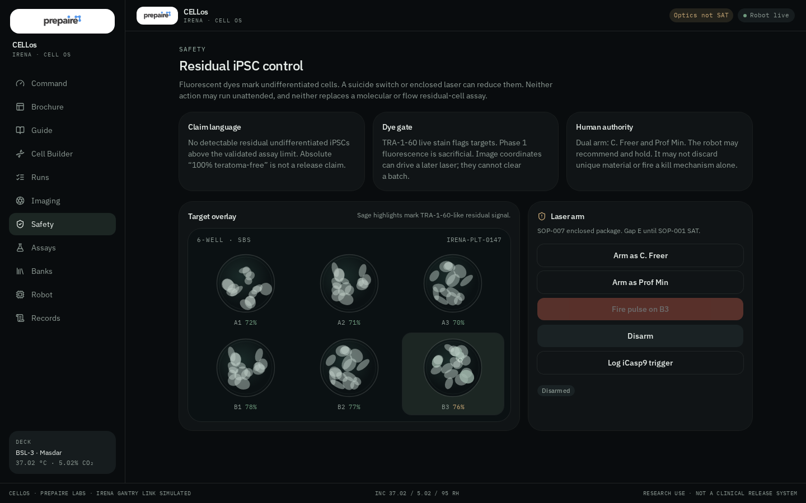
Figure 3c. Safety — dual-arm laser. It refuses until both roles are armed.
4. SAT-7 — the seven-day acceptance run
SAT-7 is protocol IRENA-BIO-SOP-001, the reference feeder-free iPSC cycle on CTS Essential 8 / vitronectin in 6-well plates. Method A uses Versene aggregates. Method B uses TrypLE, a 200 × g spin, an AO/PI count and a reseed. This is how the robot proves it can keep cells alive, identified and recorded. It is not a therapeutic product.
Day | Step | Module | Set-point / hold
0 | Create run — LIMS ID, plate map, operator, protocol version | LIMS | Hard stop on missing identity
0 | Coat vitronectin 1.0 mL, 0.5 µg/cm², 60 min, 20–25 °C | Pipettor + timer | No dry well
0 | Seed 250,000 viable cells/well in 2.0 mL E8 + RevitaCell | Counter + pipette | 25,000 cells/cm²
1 | Pre-feed whole-well brightfield | Imager | Focus score + raw TIFF
1 | Aspirate 2.0 mL from wall; dispense 2.0 mL E8 | Pipettor | Low-shear · 24 ± 2 h
2 | Image, classify, feed | Imager + pipette | GREEN feed; YELLOW review
4 | Method A Versene 1.0 mL, 37 °C 4 min | Incubator + imager | Max 6 min SAT window
4 | Method B 200 × g, 4 min; residual 0.2 mL | Centrifuge | Pellet-safe aspiration
4 | AO/PI count; reseed if viability ≥ 85% | Counter | Hold 75–85%; reject < 75%
5 | Remove RevitaCell; 2.0 mL E8 | Pipettor | Recovery image first
7 | Export batch: images, counts, environment, deviations | LIMS | Reconstructable audit

Expert note. Coating (G.04) and inline imaging (G.05) are the rate-limiting SAT items. Until they land, CELLos still schedules the steps and writes the record, but confluence scores are advisory. Do not wire a simulated classifier to an unattended passage.
5. Every screen, in order
Screen | Who it is for | What you do there
Command / | Everyone | Live run, incubator, interlocks, queue, event log, document pack.
Brochure /brochure | Visitors, partners | As-built photographs, platform schematic, specification.
Guide /guide | First-time operators | This document, condensed, with downloads.
Cell Builder /builder | Scientists | Compose from a brief or pick a product kind. Edits, dyes, switch, laser.
Runs /runs | Operators | Queue, speed, hold/resume, well plate, step timeline.
Imaging /imaging | Optics / QC | Whole-well scores, fluorescence overlay, coordinate contract.
Safety /safety | Two authorised people | Dual-arm laser and iCasp9. Neither is a release.
Assays /assays | Downstream biology | Cytotoxicity, priming, phenotype, chip, residual iPSC.
Banks /banks | Bank owners | WTC11, qKO, dKO, U266, haplobank — starting material identity.
Robot /robot | Engineers | As-built deck and the A–E gap matrix with owners and dates.
Records /records | QA / LIMS | Genealogy: bank → design → run → plate → well.

6. Cell programmes and product kinds
A programme is a versioned intent: product kind + bank + protocol + gene-edit list + dye panel + safety flags. Composing a brief is allowed to be fuzzy. Dispatching a run is not — missing identity is a hard stop.
Kind | Protocol | Days | Intent
Universal iPSC cycle | SOP-001 | 7 | Coat, seed, incubate, feed, image, classify, passage, count, reseed, record.
TumorDressed DC | RDP-002 | 38 | qKO iPSC → CD14 → migratory DC, dressed with tumour MHC-peptide vesicles.
Tissue organoid | ORG-HEART | 24 | Directed differentiation. First organ is HOLD until Prof Min signs.
Micro-tumour bed | MTX-001 | 10 | Tumour / stroma / immune as a compact cytotoxicity assay.
Organ-on-chip | CHIP-001 | 5 | Load a qualified model; independent TEST-ARTICLE chain.
iPSC CAR-NK | SOP-005 | 35 | Deferred until SOP-001 is accepted. Allogeneic bank, not patient iPSC.
Edited host | SOP-001 | 7 | Defined knockout / knock-in manufacturing host. CRISPR is off-robot.

6.1 TumorDressed, in one paragraph
RDP-002 takes a universal qKO iPSC (B2M / CIITA / PD-L1 / PD-L2 knockout, CD80/CD86 retained), forms embryoid bodies, walks them to CD14, commits to dendritic cells with GM-CSF / IL-4, matures with Mat3, dresses with U266 membrane vesicles prepared on a sidecar, primes allogeneic CD8s, and reads a 24-hour lysis. CRISPR is an input, not a robot step. Vesicle production (N₂ cavitation, 100,000 × g, 0.4 µm extrude) is a sidecar job with a barcode handshake. Flow cytometry, not the camera, is the dressing QC.
7. Safety: dyes, switch, laser, residual iPSC
Undifferentiated iPSC that escape into a differentiated product are a teratoma risk. CELLos encodes three layered controls and refuses to call any of them a release.
- Dye gate. TRA-1-60 live stain flags residual cells. Phase 1 fluorescence wells are sacrificial. Image coordinates can later drive a laser; they cannot clear a batch.
- Suicide switch. NANOG-iCasp9 is a property of the engineered bank, not of the gantry. Triggering it is logged. Orthogonal assay still required.
- Enclosed laser. SOP-007. Dual authorisation (operator + reviewer). No unattended kill. After a pulse, residual-iPSC image flag falls; the release assay does not.
Claim language that is allowed: “No detectable residual undifferentiated iPSCs above the validated assay limit.” Claim language that is not allowed: absolute “100% teratoma-free.”
8. Identity, banks and the batch record
Off-the-shelf therapy comes from a qualified allogeneic bank. Patient material builds assays. Haplobank coverage is a scale model, not a clinical claim until FTO and GMP translation.
Bank | Line | Edits | Status
WTC11 working bank | GM25256 / WTC11 | Wild-type, MHC competent, P18 SAT window | Released (research)
Universal qKO | IRENA-qKO-04 | B2M / CIITA / PD-L1 / PD-L2 KO; CD80/86 retained | Released (research)
B2M/CIITA dKO | IRENA-dKO-02 | Comparator; upgrade before functional SAT | Qualification
U266 myeloma source | U266 | HLA-bearing membrane donor for dressing | Released
Haplobank A*02:01 | HB-A02-hom | HLA-homozygous, switch-ready | Qualification

Genealogy, always reconstructable: bank → design → run → plate (e.g. IRENA-PLT-0147) → well. Every motion, image, count, sidecar job and override belongs in that chain. CELLos is the LAM surface until the site LIMS handshake is SAT (gap G.15).
9. Hardware boundary and connected systems
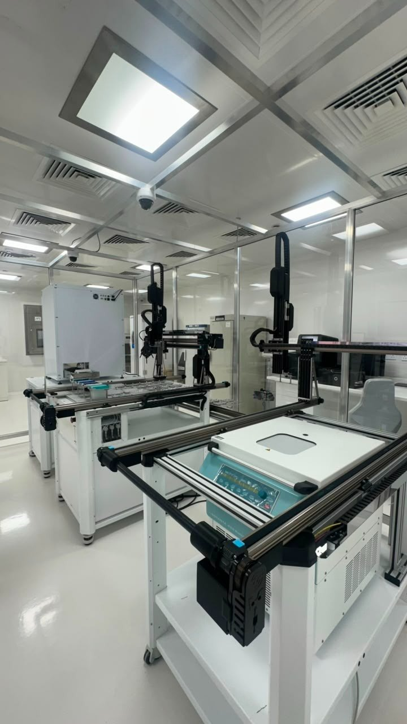
Figure 5. Sliding-stage incubator handoff on the right-hand station.
The workcell is a gantry plus sidecars, not a fantasy of putting every instrument on one rail. Things that belong on the gantry: plate transport, pipetting, timed detachment, pellet aspiration, incubator load. Things that do not: ultracentrifuge, N₂ cavitation, magnetic selection (until a closed magnet exists), clinical-grade flow, gene editing.
9.1 NeXCell R series — connected incubator
Waken Tech NeXCell R is the environmental sidecar CELLos already speaks as “incubator.” Model family NR28 / NR48 / NR100 / NR150. Internal HEPA to ISO Class 5 within 10 minutes. Cassette hotel. Sliding plate stage and optional side gate for robot access. RS-232 (RS-485) and Ethernet. Optional low O₂ (N₂), ultrasonic humidity, VHP H₂O₂ decontamination, barcode reader. Average robotics load/unload: max 25 seconds.
Item | NeXCell R (NR28 class)
Temperature | Pt100 Class A · 37.0 °C ±0.5 · uniformity ±1.0 at control point
CO₂ | NDIR · 0–20.0% · ±0.5%
O₂ (option) | Zirconia · 1.0–20.0% · ±1.0%
Air | DC blower through HEPA
Chamber | SUS304 uncoated #200 or more
Vessels | Microplates, 100/150 mm dishes, T25/T75 (T175 on NR150)
CELLos mapping | Slot identity, temp/CO₂/RH trend, load/unload interlock, decontamination flag

9.2 What stays a sidecar
- AO/PI cassette counter — structured JSON into LAM (G.09).
- EasySep CD14 / CD8 — barcode handoff now, closed magnet later (G.10).
- N₂ cavitation + 100,000 × g + 0.4 µm extrude — job scheduler, not gantry (G.11).
- Flow cytometry — FCS export, versioned panel, never camera-only release (G.12).
- Laser package — enclosed, dual-role, after SOP-001 (G.13).
10. Software architecture
CELLos is a TanStack Start application (React 19, Vite 8, Nitro). Routes live in src/routes. The protocol catalogue, banks, dyes, organs and gap matrix are versioned TypeScript in src/lib/catalog.ts — that file is the scientific source of truth for this edition, not a CMS. Operator state is a Zustand store (src/lib/store.ts) with a persist slice limited to people and designs; live wells and logs are session-ephemeral so a demo cannot silently become a false batch record.
The composer (src/lib/compose.ts) is a server function. If XAI_API_KEY is present it structures a biologist brief against a closed vocabulary (product kind, bank, dyes, flags). If not, a deterministic local parser does the same job. CRISPR is never offered as an on-robot step. Laser and iCasp9 always require dual control in the UI regardless of how the brief was written.
There is no patient database, no auth wall, and no destructive “delete all” in this edition. Unowned demo rows would be world-writable; personal or clinical data must not be stored here. Auth remains off until a named accounts requirement exists.
10.1 Colour language on the plate
- GREEN — confluence and differentiated-area inside advisory limits. Feed is allowed.
- YELLOW — edge merge, high confluence, or differentiated-area 5–10%. Review. No autonomous passage.
- RED — differentiated-area > 10% or overconfluence. Automatic reseed blocked. Scientist disposition required.
11. Feynman App Store deployment
CELLos is published to the Feynman Labs App Store from GitLab project feymanlabs/cellos. The public address is /apps/cellos/. The process is a long-running Node server.
Setting | Value
Runtime | Node.js 22
Install | npm install --include=dev
Build | NITRO_PRESET=node-server npm run build
Start | HOST=0.0.0.0 PORT=$PORT npm start
Bind | 0.0.0.0 and platform PORT
Public path | /apps/cellos/ (APP_BASE_PATH / VITE_BASE)
Liveness | GET /healthz → { ok: true, service: "cellos" }
Health also at | /apps/cellos/healthz
Manifest | feynman.deploy.json

Local Grok preview stays at origin / on port 8080 and must not inherit VITE_BASE=/apps/cellos/. Docker image in ./Dockerfile builds the Nitro node-server output and HEALTHCHECKs /healthz.
12. Gap matrix (as of September 2026)
Status letters: A live on the machine · B qualify in software · C missing module · D sidecar · E deferred. Dates are engineering targets, not promises to a clinic.
Ref | Operation | St | Owner | Note
G.01 | Plate transport | A | Sergey | 100 consecutive transfers still to evidence
G.02 | Centrifuge + pellet aspiration | A | Sergey | Gravimetric residual during OQ
G.03 | Chemical detachment | B | Evgeny | Lock liquid classes vs manual comparator
G.04 | Vitronectin / Geltrex coating | C | Evgeny | Cooled matrix nest · 17 Oct
G.05 | Inline whole-well imager | D | Optics | Celigo-class · highest priority
G.06 | Confluence classifier | C | Analytics | Advisory only in Phase 1
G.07 | Image-guided EB transfer | C | Evgeny | Do not scrape aggregates
G.08 | 2–8 °C cytokine station | C | Sergey | Dedicated cold nest
G.09 | Automated cell counter | D | Evgeny | AO/PI JSON into LAM
G.10 | CD14 / CD8 magnetic selection | D | Biology | Handoff now / closed magnet later
G.11 | N₂ cavitation + ultracentrifuge | D | Process | Not on the gantry
G.12 | Flow cytometry | D | Core lab | FCS export, not camera-only
G.13 | Laser residual-cell ablation | E | Carl / biosafety | After SOP-001, dual authorisation
G.14 | NANOG-iCasp9 switch | E | Prof Min | Bank property, not a robot feature
G.15 | Electronic batch record | C | Software | CELLos is the LAM surface

13. Glossary
AO/PI Acridine orange / propidium iodide dual nuclear stain for live/dead counts.
BSL-3 Biosafety level 3 envelope. IRENA’s room classification in Masdar.
EB Embryoid body — 3D aggregate used on the way to hematopoietic lineages.
iCasp9 Inducible caspase-9 suicide switch, here gated on NANOG (pluripotency).
iPSC Induced pluripotent stem cell. Starting chassis for the platform.
LAM Laboratory automation manager — CELLos in this edition.
MCB Master cell bank. Manufacture starts from a vial of a released clone.
qKO Quadruple knockout (B2M, CIITA, PD-L1, PD-L2) universal immune chassis.
SAT Site acceptance test. SAT-7 is the seven-day iPSC cycle.
TRA-1-60 Live pluripotency surface marker used as the residual-cell dye gate.
TumorDressed qKO DC product dressed with tumour membrane vesicles (RDP-002).
WTC11 Well-characterised healthy-donor episomal hiPSC (GM25256), 46,XY.
14. Troubleshooting
What you see | What it actually means | What to do
Optics GAP on Command | Inline imager is not SAT. Classifier is advisory. | Do not pass on image alone. Keep shooting the record.
Laser button does nothing | Both roles have not armed. | Operator arms, reviewer arms, then pulse. It will disarm after fire.
Run goes to HOLD on B3 | Simulated RED / high differentiated-area. | Read the log. Resume is a human disposition, not a retry loop.
Compose returns iPSC cycle unexpectedly | Brief did not match TumorDressed / organoid / NK cues. | Name the product (“dressed DC”, “cardiac organoid”) and compose again.
/healthz fails on Feynman | Process is bound on the wrong port or build missing. | Confirm PORT, npm start, and .output/server/index.mjs.
White logo looks like a box | Prepaire wordmark is dark-on-white by design. | It sits on a white chip in the dark OS. That is intentional branding.

Document control. CELLos Technical Documentation v1.0. Authoring system: CELLos itself. Audience: IRENA operators, Prepaire scientific staff, Feynman Labs App Store reviewers, visiting engineers. Classification: internal / partner — not for clinical labelling. Photographs: IRENA suite, 21 September 2026. NeXCell R specifications: Waken Tech Co., Ltd. brochure Rev.1, used as the connected-incubator reference.

